Day 1 Homework

Task 1: Setup of service now
Created an account and a PDI and logged in the system
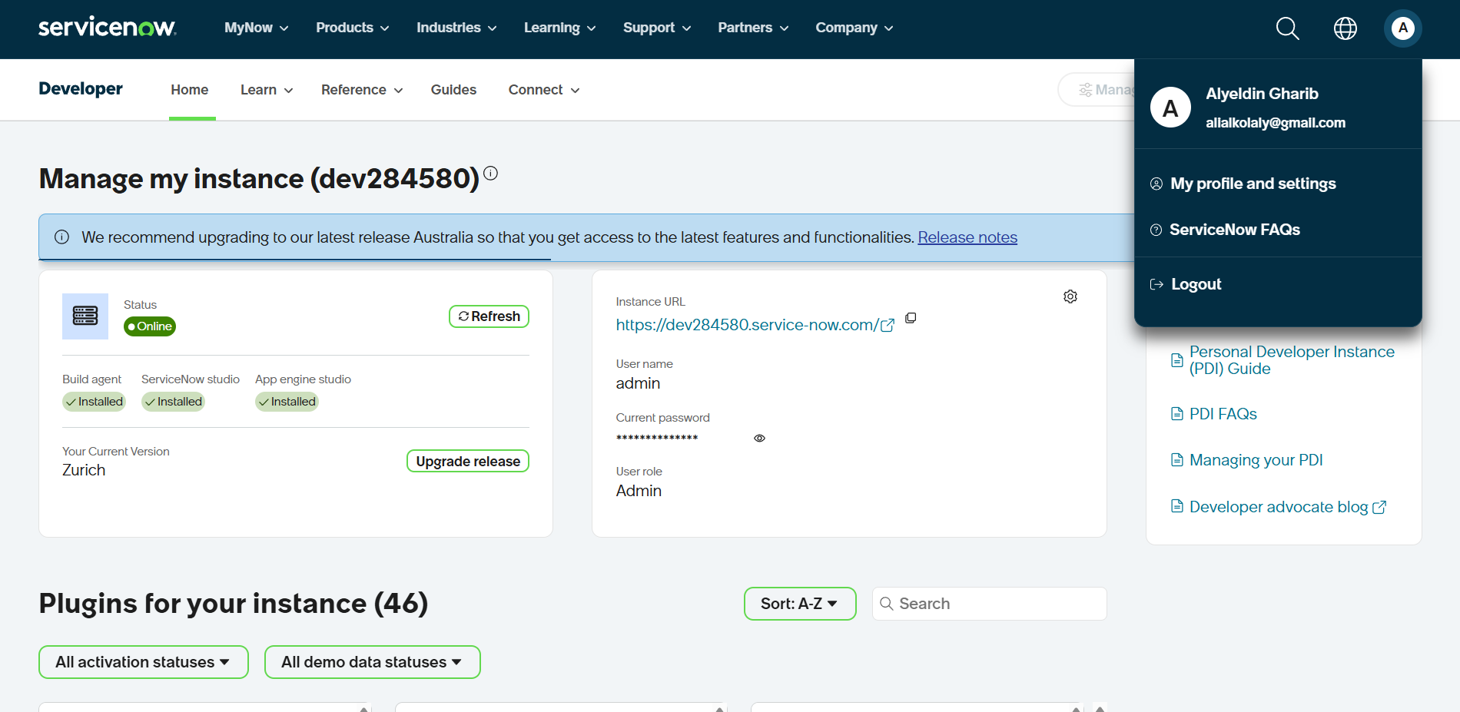

Task 2: Navigation Practice
Searched for Incidents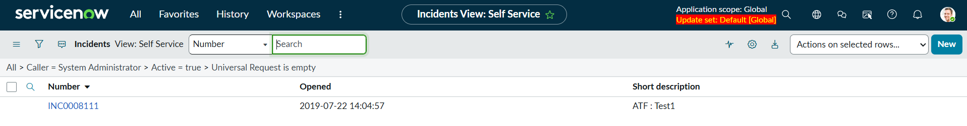
incident.do
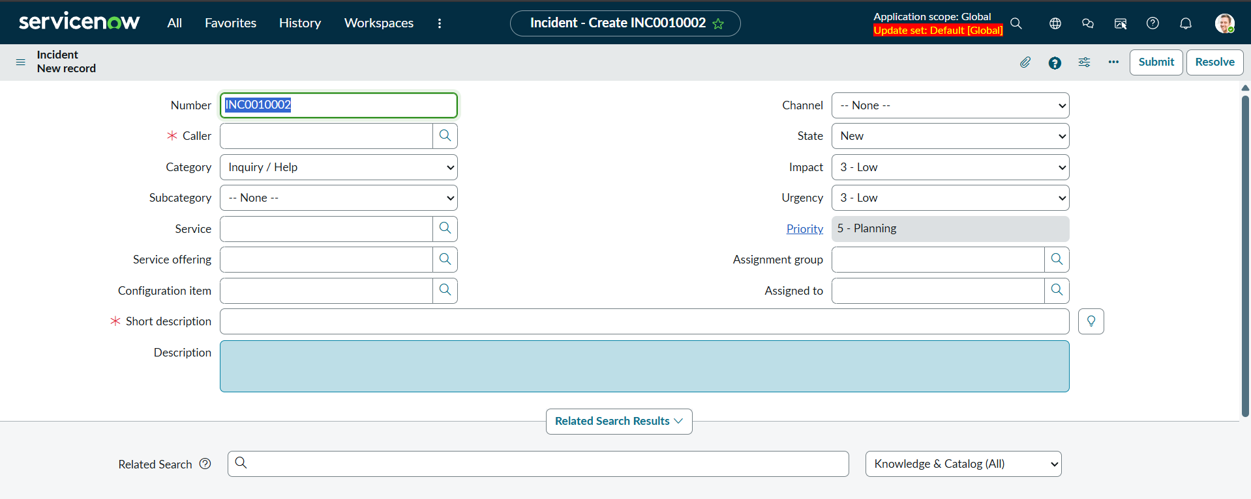
Sys_user.do
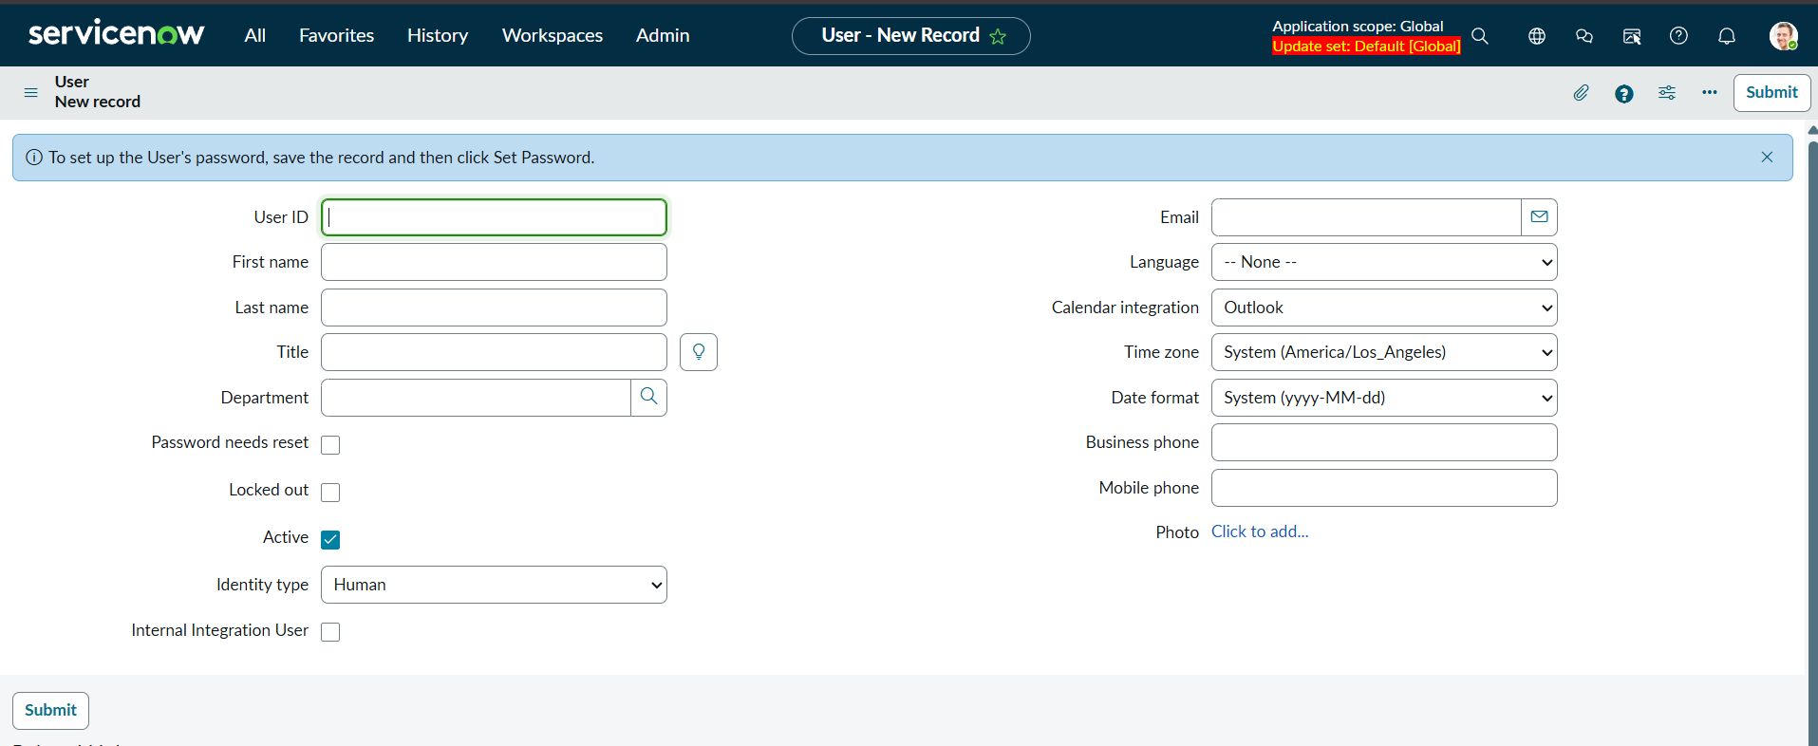
Sys_user_group.do
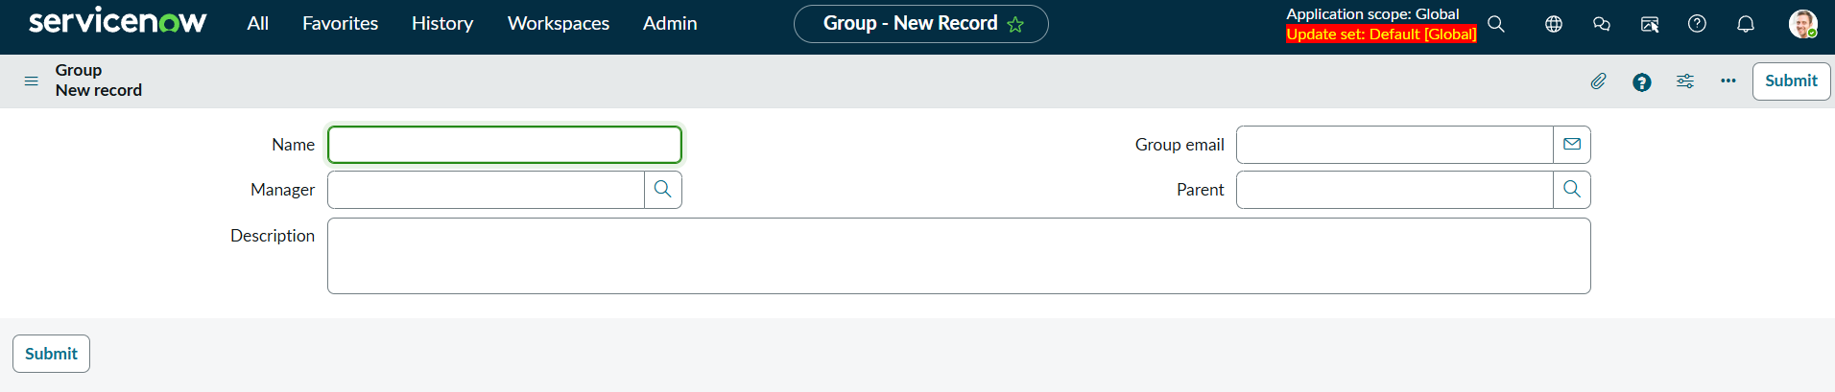

Task 3: Incident Practice
Created 7 incidents with different priorities and updates some of their status and assigned them to certain groups
